Yong hui Report

Executive Summary
- Introduction
This report analyzes Yonghui Supermarket’s 2019–2025 performance, operational challenges, and transformation, benchmarking regional leader Pangdonglai to identify strategic paths. Amid China’s retail sector’s fierce competition and shifting demands, Yonghui went through expansion, adjustment, and transformation, while Pangdonglai achieved sustained profitability via regional deepening—offering key insights for Yonghui and other retail companys.

- Background
Yonghui’s revenue peaked at RMB 93.2 billion in 2020, declining steadily to 2024, with store count dropping to 775. Its 2020–2024 gross margin stabilized at 18%–22%, but operating profit faltered due to three core issues: worsening single-store performance, high inventory pressure, and concentrated regional revenue without margin premium. It launched Pangdonglai-guided transformation in 2024.
Pangdonglai bucked industry trends with steady growth, driven by a low-cost supply chain, Henan regional focus, and people-oriented policies forming a virtuous cycle—validating transformation feasibility for Yonghui.

- Transformation
Yonghui’s May 2024 transformation covered key cities, renovating 222 stores by Q3 2024 (modeled after Pangdonglai) with store upgrades, supply chain reform (naked-price direct sourcing), and brand restructuring. Two product series with over 20 premium items achieved cumulative sales exceeding RMB 100 million since October 2024. Post-transformation, revenue continued to decline but with narrowed fluctuations; short-term profitability weakened, yet 2025 Q1–Q3 same-store sales turned positive, signaling core business recovery. Capital-market reaction validates this pivot: Yonghui’s stock returned +124.8% in 2024, with the Miniso stake-offer event window generating +61.3%.

- Advices
Recommendations: 1) Prioritize efficient store renovation, avoid reckless expansion; 2) Deepen supply chain reform (direct sourcing, SKU optimization, private labels); 3) Integrate online-offline channels, expand instant retail, cut costs digitally; 4) Optimize capital via private placements and inefficient asset disposal; 5) Rebuild brand around "quality" for long-term trust.

- Conclusion
Yonghui’s over-reliance on scale over efficiency and rigid costs caused losses. Pangdonglai’s "people-oriented, regional deepening" model proves "quality over scale" is retail’s long-term profit key. Through operational analysis of Yonghui and Pang Donglai, it helps to provide diverse perspectives and concrete experience for transformation and innovation of retail enterprises in the declining environment of the Chinese retail market.
1.1 Revenue Quality and Decomposition
(1) Overview of Revenue Performance
This part analyzes the revenue performance and quality of Yonghui Supermarket from 2019 to 2024. The period shows a clear cycle from expansion to deep strategic adjustment. Total revenue peaked in 2020 at approximately RMB 93.2 billion before entering a sustained decline, falling to about RMB 67.6 billion by 2024. In contrast, the store network expanded to a high of 1,057 stores in 2021 before contracting sharply to 775 stores in 2024(See Figure 2.1.1 in Appendix). The divergence between these trends (revenue decline outpacing store reduction) indicates that past growth heavily relied on network expansion rather than improved store efficiency.
(2) Analytical Framework: Revenue Decomposition
To diagnose the nature of revenue changes, we decompose the annual change in revenue into two distinct drivers:
Store‑Count Effect: The impact purely from opening or closing stores, measuring scale change.
Same‑Store Effect: The change in sales performance of existing stores, reflecting operational quality and customer demand.
This decomposition is based on a counterfactual Assumed Revenue, calculated as Last Year’s Revenue per Store × This Year’s Store Count. Sustainable, healthy growth should be primarily driven by a positive Same‑Store Effect. Please refer to Table 2.1.2 for the calculation process.
(3) Key Findings
The decomposition reveals two distinct phases (please see Figure 2.1.3):
- Phase 1: The Erosion (2020–2023)
During this phase, revenue change was primarily driven by a consistently negative Same‑Store Effect. In 2020, all growth came from new stores, masking an underlying decline in same‑store sales. In 2021 and 2023, the severe negative Same‑Store Effect was the main cause of revenue loss, indicating a systemic weakening of the store model. Store closures in 2022–2023 were insufficient to offset this core deterioration.
- Phase 2: The Strategic Pivot (2024)
The story changed sharply in 2024. The massive revenue drop was almost entirely due to the Store‑Count Effect from closing 225 stores. Crucially, the Same‑Store Effect turned strongly positive, showing that the remaining, smaller store network achieved significantly higher sales per store. This signals a deliberate shift toward a smaller, more focused, and healthier store base.

1.2 Gross margin side and expense-side
(1) Gross Margin Stability Amidst Profitability Collapse
Contrary to expectations of margin compression, Yonghui’s gross margin demonstrated notable stability, fluctuating within a band of 18% to 22% during the five-year period. This indicates that the fundamental profitability of its core merchandising operations remained largely intact. However, a stark divergence occurred at the operating profit level. As illustrated in Chart 1, the company’s core net profit turned negative in 2021 and remained deeply negative thereafter. This clear dissociation between stable gross margin and collapsing bottom-line profit signals that the critical failure point resides not in the cost of goods sold, but in the structure and behavior of operating expenses.
(2) Expense-Side Rigidity and the “Scissors Effect”
Chart 2 reveals the destructive “scissors effect”. While total revenue entered a steady decline since 2020, the net profit margin deteriorated at a significantly steeper rate, widening the gap between top-line and bottom-line performance. This pattern is a classic indicator of high fixed-cost rigidity. Expenses such as store leases, depreciation, and basic payroll could not adjust downward proportionally with the declining revenue base. Consequently, these fixed costs created powerful negative operating leverage, systematically amplifying losses as sales contracted.
(3) Structural Proof: Complete Erosion of Gross Profit
A static decomposition of the 2024 profit stream (Chart 3) provides definitive evidence of the expense-side problem’s magnitude. It shows that the entire gross profit of approximately RMB 13.82 billion was completely offset by operating costs and expenses totaling RMB 16.23 billion, resulting in a net operating loss of RMB 2.41 billion. This analysis identifies the expense side as the direct agent of profit destruction, confirming that the scale of costs has surpassed the company’s ability to generate sufficient gross profit to cover them.
(4) Compounding Pressure: The Trend of Rising Expense Ratio
The static view is further exacerbated by a concerning dynamic trend. Chart 4 tracks the operating expense ratio. This ratio has been on a persistent upward climb since 2022, coinciding with the period of operational losses. This trend indicates that the cost burden is not only rigid but also intensifying relative to revenue. Even in a scenario of revenue stabilization, a continuously increasing portion of each sales yuan is consumed by structural costs, perpetually constricting any potential path back to profitability under the current model.
(5) Synthesis of Findings
The sequential analysis, moving from stable margins to the scissors effect, profit decomposition, and finally the rising expense ratio, constructs a coherent narrative. This structure failed to adapt to a contracting revenue base, triggering negative operational leverage. The problem is both absolute, as seen in the profit decomposition for a single year, and relative, as evidenced by the worsening expense ratio over time. This diagnosis shifts the focus from Yonghui’s sales and margin capabilities to the imperative of strategic cost structure transformation.

1.3 Operational Factors Behind Yonghui’s Profitability Decline
(1) Store Expansion and Single-Store Performance
As shown in the graph for section 2.3.1, Yonghui continuously expanded its store network between 2020 and 2022. In 2022, the total store number reached its maximum of 1045. After that, Yonghui entered the stage of integration and contraction, reducing the store number to 887 by 2024. However, this strategy actually did not bring significant improvement in the single store performance. According to the data provided, during the sample period (2020-2024), the average revenue of individual store declined consistently from 93.25 million to 76.14 million. It reflects the weakening of Yonghui's sales efficiency and customer traffic quality at the single store level. Moreover, in 2021, Yonghui’s operating profit per store sharply dropped to -4.56 million, and then the number remained negative in the following years. Although there is some improvement after 2022, the profit still failed to get back to the positive level. These facts have shown that Yonghui’s expansion strategy did not generate economies of scale, but diluted the profitability of single store, leading to a negative impact on the overall profit.
(2) Persistently High Inventory Turnover Days
According to the graph for Section 2.3.2, Yonghui has been subject to sustained inventory pressure, its inventory turnover days exceeded 50 days in most years, and it peaks in 2023. Although there is a slight improvement in 2024, the overall level is still high. Given Yonghui’s fresh-food–oriented business model, high inventory intensity implies greater spoilage risk, higher capital tied up in inventory, and limited room for inventory adjustment. This structural feature makes cost pressure continuous rather than short-term fluctuations. Even when revenue stabilizes, elevated inventory levels continue to constrain improvements in gross margin and profitability.
(3) Regional Revenue Concentration and Margin Implications
As illustrated in the graph for 2.3.3, Yonghui’s revenue is clearly concentrated in a few core regions. The East and West regions together contribute more than 40 percent of Yonghui’s total revenue, suggesting a relatively high concentration of revenue across regions. Nevertheless, these high-revenue regions do not generate higher gross margins. Their margin levels remain moderate and are broadly comparable to those of other regions. This implies that Yonghui’s revenue growth has mainly come from regions that are also cost-intensive, without providing a clear margin advantage. From a weighted perspective, changes in the regional revenue structure have not improved overall gross margins. Instead, they have a dilution effect on the overall profitability in the presence of cost and cost rigidity.

2.1 Overview and Business Model Analysis of Pangdonglai
(1) Company Overview
Pangdonglai was founded by Mr. Yu Donglai in Xuchang in 1995 and has since established a deep-rooted presence in the Henan regional market. Currently, the company operates 11 stores in Xuchang and 3 in Xinxiang, with sustained growth in financial performance. Between 2020 and 2024, its sales revenue increased from 7.85 billion yuan to 12 billion yuan, while its net profit surged significantly from 450 million yuan to 1.05 billion yuan.
(2) Three Main Unique Business Strategies
The uniqueness of Pangdonglai’s business model lies in three core pillars: low-cost initiatives, generous employee benefits, and customer-centricity.
- Firstly, in terms of products and supply chain, 80% of the company’s supply chain is localized. In 2001, it established a "four-party joint procurement" model in cooperation with three enterprises (Xiya Hemei, Wan DeLong, and Luoyang Dazhang), which significantly reduced procurement costs. Meanwhile, it has vigorously developed private labels, accurately matching the core demands for quality and cost-effectiveness among China’s middle-to-high-income groups— the mainstay of the future consumer market.
- Secondly, adhering to a customer-centric philosophy, it has built a strong reputation through exceptional services, which has translated into high brand loyalty and effectively lowered marketing costs.
- Finally, at the operational level, it adheres to a region-centric strategy, deepening its presence in local markets and avoiding blind expansion. Simultaneously, it offers an industry-leading benefits package for employees: in 2025, the average monthly salary of ordinary store employees reached 9,886 yuan (Graph 3.1.1), the employee turnover rate was only 5% (far below the industry average of 20%), and annual leave lasted 140 days (nearly double the industry average of 68 days).
These initiatives have fostered a highly motivated and loyal team, ensured the delivery of high-quality services, and ultimately formed a virtuous cycle: “generous employee benefits → high-quality services → highly loyal customers → sustainable profitability → generous employee benefits”. In summary, Pangdonglai has gained a high brand reputation with its people-oriented philosophy of “Not making money, winning people's hearts”.

2.2 Comparison of Pang Donglai and Yonghui
(1) Business Philosophy and Strategic Implications
Although Pang Donglai and Yonghui operate within the same grocery retail industry, their development paths differ significantly due to contrasting business philosophies. These differences in values directly shape their operating focus, profit models, product strategies, and management approaches.
lPang Donglai: Adopts a people-centered value orientation, emphasizing employee well-being, customer experience, and long-term trust rather than short-term profit maximization.
lYonghui: Followed a scale- and efficiency-oriented logic, focusing on rapid expansion, supply chain optimization, and cost control.
In terms of operation focus, Pang Donglai positions itself as a boutique community store. Its stores are designed as experiential spaces, transforming grocery shopping into an experience rather than a purely transactional activity. Yonghui, by contrast, has traditionally operated as a large-scale hypermarket, emphasizing wide assortment, high turnover, and market coverage.
These different priorities result in distinct profit models. Pang Donglai relies on high unit value density, supported by self-operated and processed products, experience premiums, and fast inventory turnover. Yonghui has historically depended on supplier entry fees and rebates, reflecting a low-value, scale-based profit structure that has come under increasing pressure as competition intensifies.
Differences are also evident in product strategy and management culture. Pang Donglai adopts a highly selective product approach with transparent quality control, reinforcing consumer trust. Its management philosophy is service-driven and people-oriented. Yonghui has traditionally emphasized comprehensive coverage and system-based management, though it is gradually shifting toward experience efficiency.
(2) Learning from Pang Donglai
lEnhancing user experience through community-oriented spaces
lShifting from system management to service-driven operations
lDeveloping a more selective supply chain with tighter SKU control
lStrengthening self-operated and processing capabilities to build trust premiums
(3) Preserving Yonghui’s Core Advantages
At the same time, Yonghui should preserve its inherent strengths, including extensive regional coverage, strong digital infrastructure, and a robust fresh food supply chain that meets daily consumption needs at scale. In conclusion, Yonghui’s optimal path lies not in imitation, but in becoming a more refined version of itself by integrating experience-driven practices with its existing scale and efficiency advantages.

2.3 Yonghui’s Financial Performance after Transformation and Development
(1) Overview of Transformation Strategy
Yonghui started transformation in May 2024, the revamped stores covered first-tier cities, as well as core business districts in new first-tier cities. This has showcased a sound development trend, validating the long-term value and feasibility of the transformation strategy. And by the end of the third quarter, Yonghui has completed the transformation of 222 stores in line with the Pang Donglai model, forming a scale effect and demonstrating an overall positive momentum. The transformation covers store upgrading, supply chain reform, and brand restructuring, with the first batch of flagship products gaining market validation and reform effects gradually emerging.
(2) Supply Chain & Product Reform
As a cornerstone of long-term development, supply chain reform adopts naked-price direct sourcing to eliminate intermediary markups and traditional channel costs. Though short-term profit structure is affected, the model has been value-proven. In product development, Yonghui targets 200 core strategic partners and 100 100-million-yuan flagship products within three years. To date, two series ("Yonghui Custom" and "Quality Yonghui") and over 20 quality products have been launched, with cumulative sales exceeding 100 million yuan since October.
(3) Financial Performance after Transformation (2024-2025) (See Tables and Graphs in Appendix)
- Operating revenue showed a sustained decline with narrowing fluctuations: from 21.665 billion yuan in 2024Q1 to 12.486 billion yuan in 2025Q3, with the year-on-year decline widening to 25.55% in 2025Q3. This is attributed to transformation impact, fierce industry competition, and weak consumer demand.
- Profitability deteriorated: net profit shifted from 736 million yuan in 2024Q1 to sustained losses, with 5 losing quarters. Core business profitability (net profit after non-recurring gains/losses) also declined, affected by revenue drops and transformation expenses, though Q1 profits benefited from seasonal and festival factors. Notably, cumulative same-store sales in the first three quarters of 2025 returned to positive growth, signaling core business recovery.
(4) Market Validation: Stock Price Reaction to the Transformation (See Tables and Graphs in Appendix)
Capital-market data from CSMAR (TRD_Dalyr and TRD_Mnth) provides an external validation of Yonghui’s transformation narrative. After pricing in the breakdown of the scale model (the stock fell 43.6% in 2021, the first loss-making year), 2024 became a turning point: Yonghui’s annual stock return reached +124.8%. Event-study windows around transformation milestones confirm investor optimism: the May 31, 2024 announcement of the Pangdonglai-style turnaround generated a [-1,+7] return of +6.7%, while the September 23, 2024 Miniso 6.27-billion-yuan offer for a 29.4% stake triggered a sharp +61.3% return. These market reactions support the operational evidence that the remaining store network is improving and that the quality-over-scale strategy is being rewarded by investors.
(5) Future Recommendations
Yonghui will renovate 450 stores for efficiency, avoid reckless expansion, and enhance services to drive customer loyalty. It will integrate online-offline channels, expand instant retail, and use digital tools to cut costs. Capital management will be optimized via private placements and inefficient asset disposal. Following the Pang Donglai model, it will prioritize quality, invest in talent and product optimization, and rebuild the brand around "quality" to foster long-term trust.

Appendix 1 Tables, Figures and Calculations
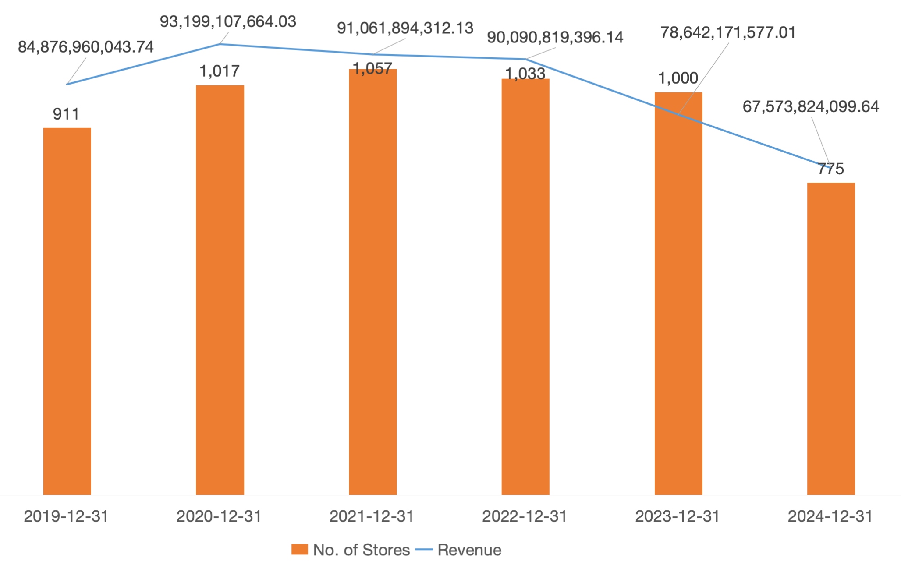
Figure 1.1.1 Overall revenue and number of stores
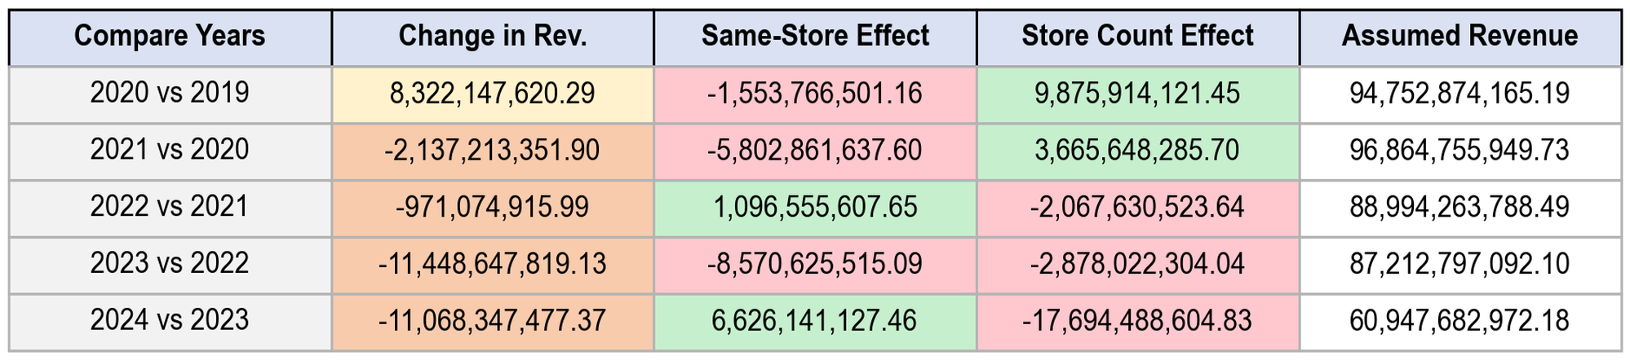
Table 1.1.2 Revenue Decomposition Calculation Process, the revenue change is split into Same-Store Effect and Store Count Effect
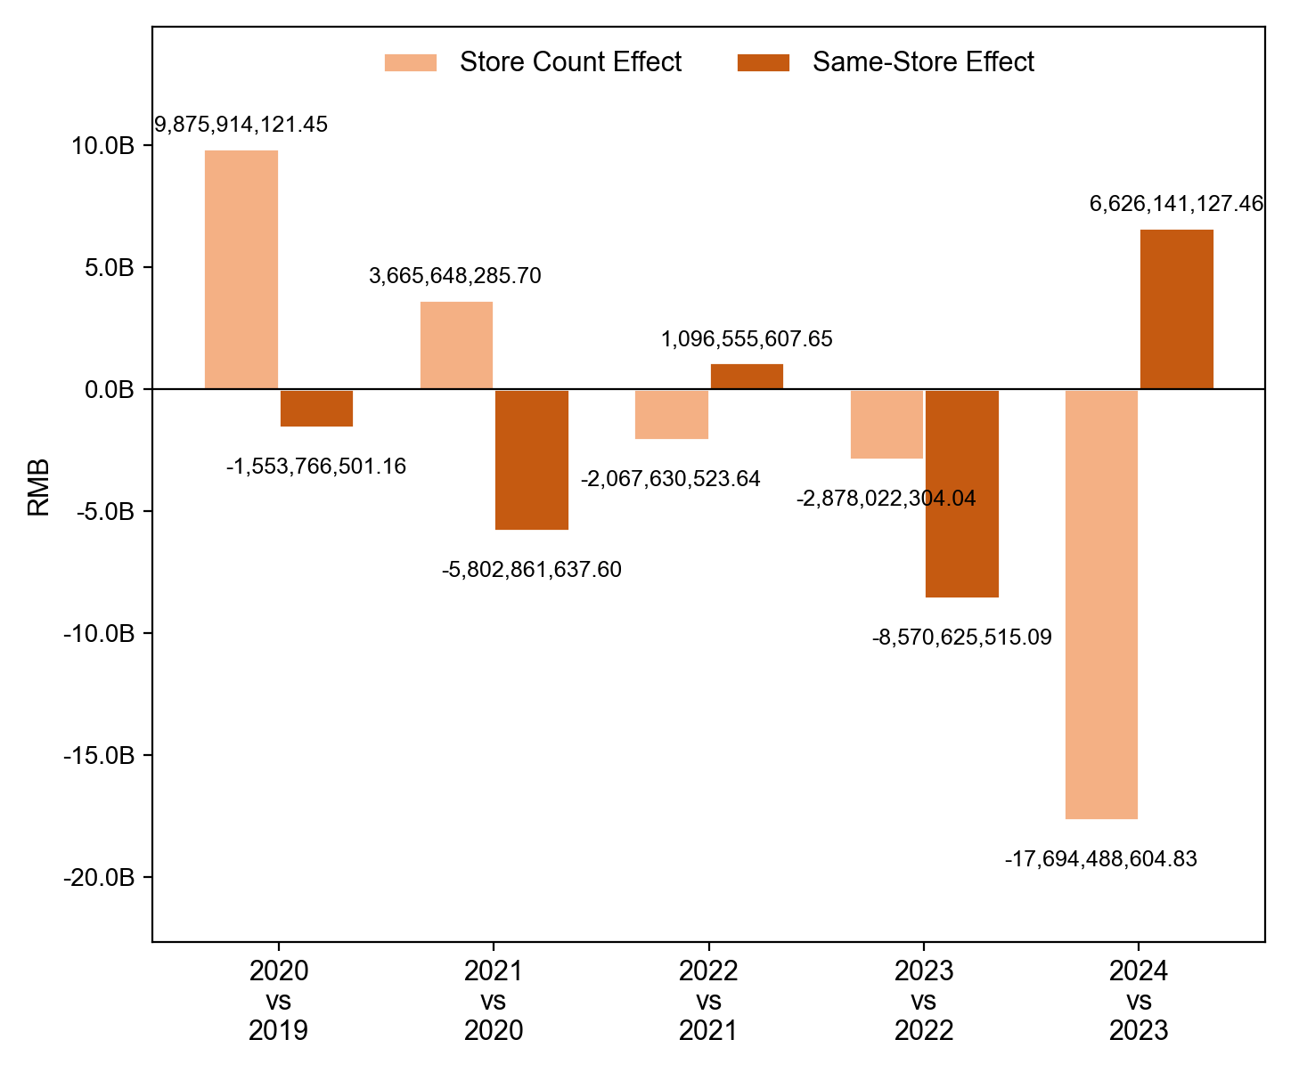
Figure 1.1.3 Revenue Decomposition visualization
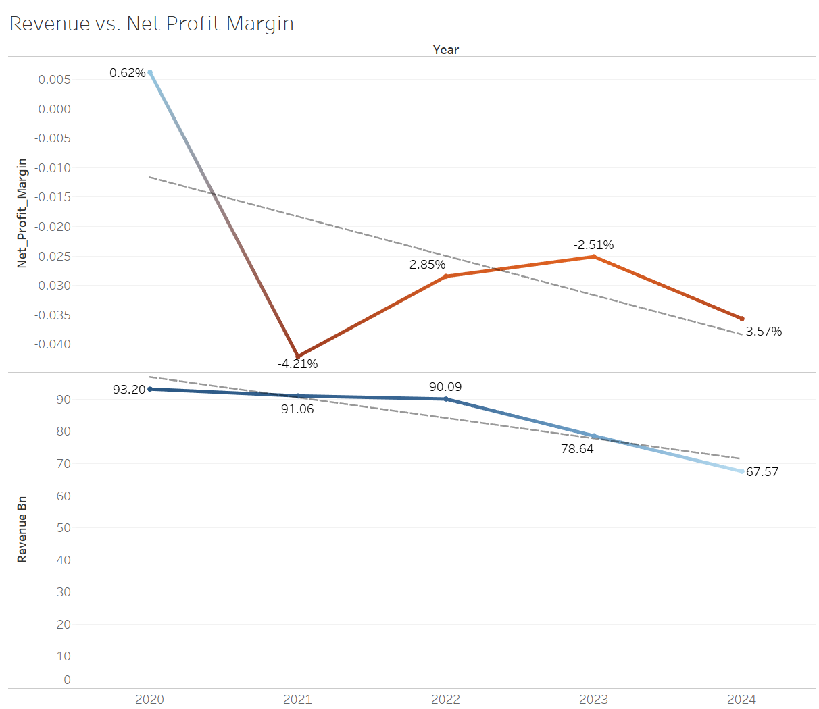
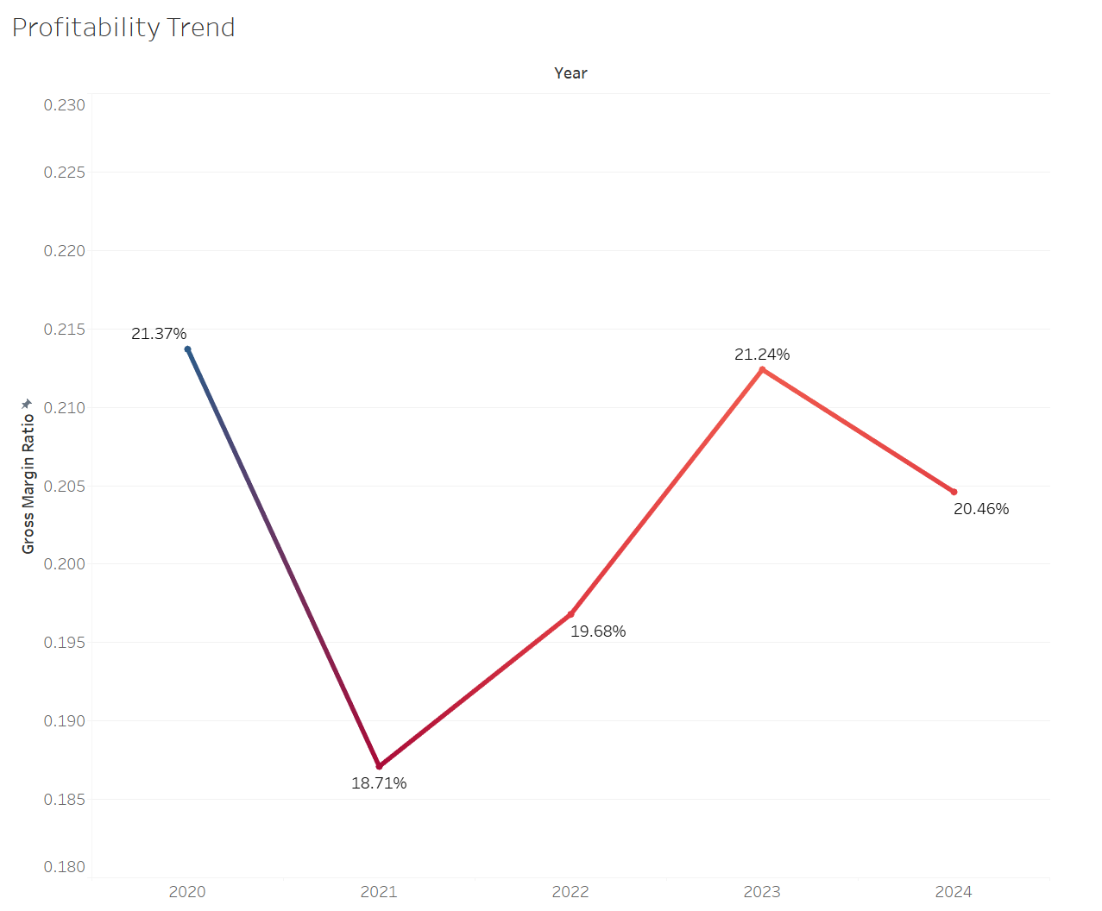
Graph for section 1.2
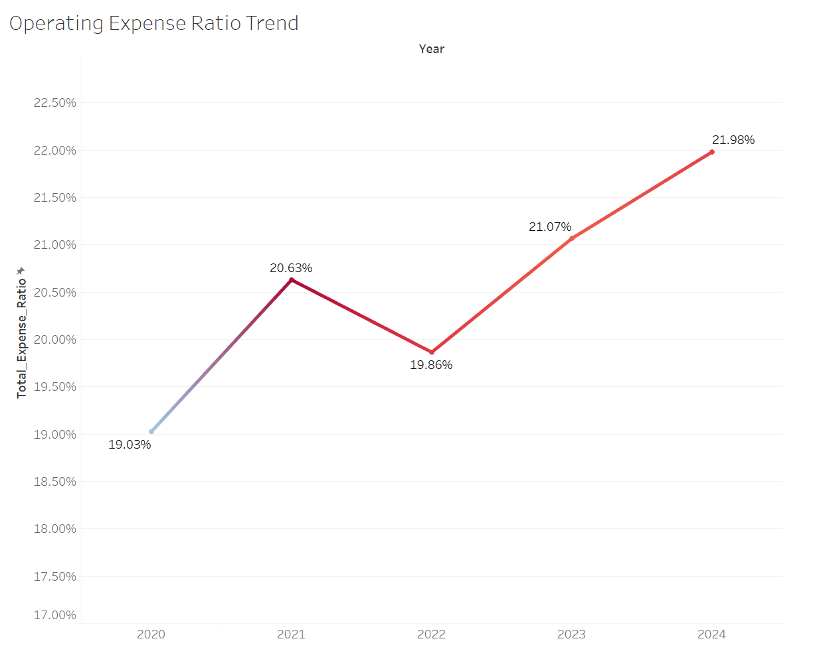
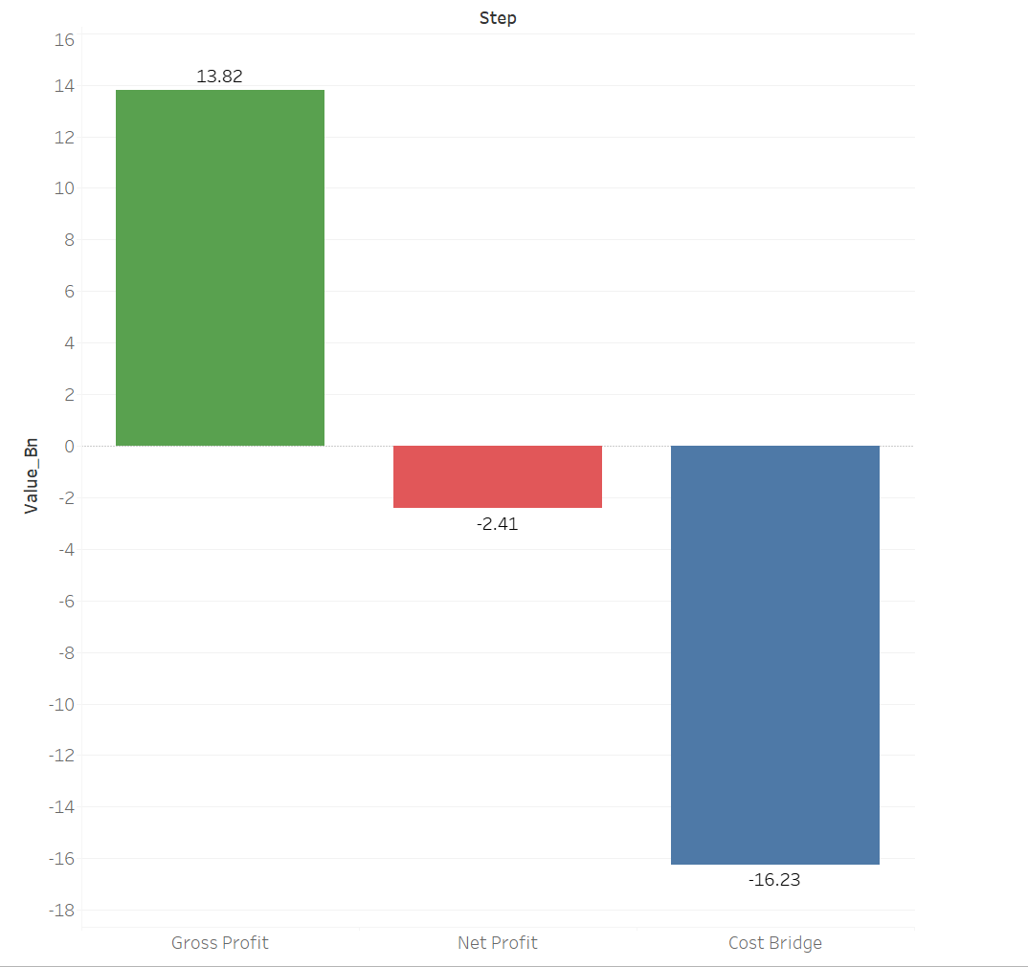

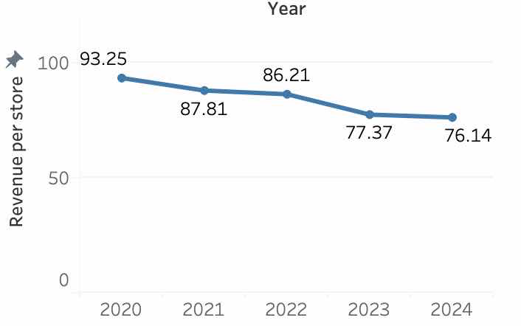
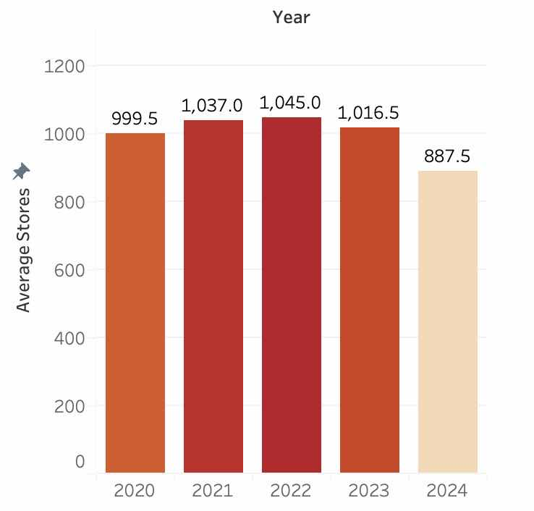
Graph for section 1.3.1
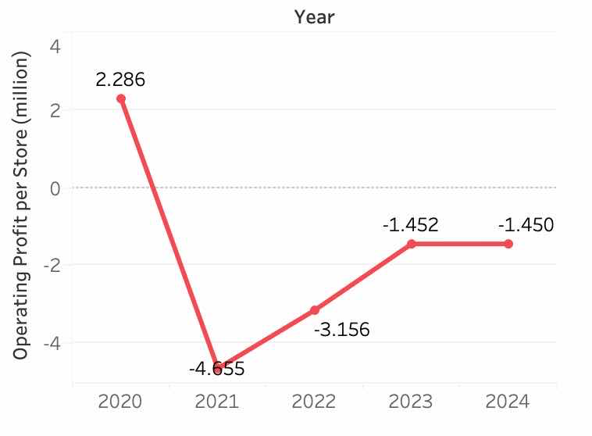
Graph for section 1.3.2
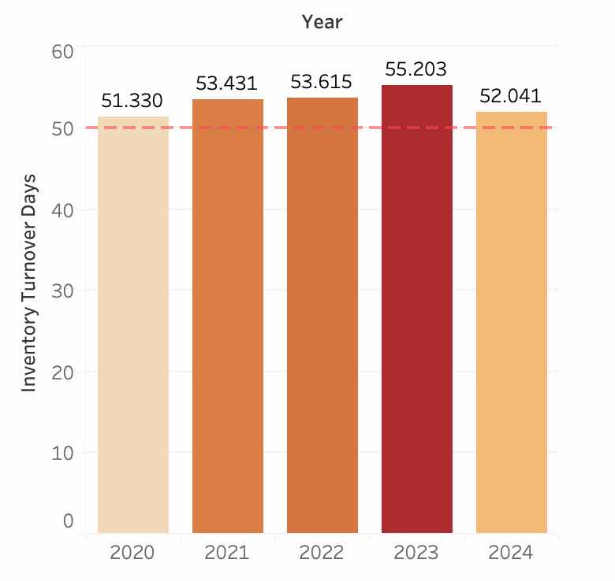
Graph for section 1.3.3
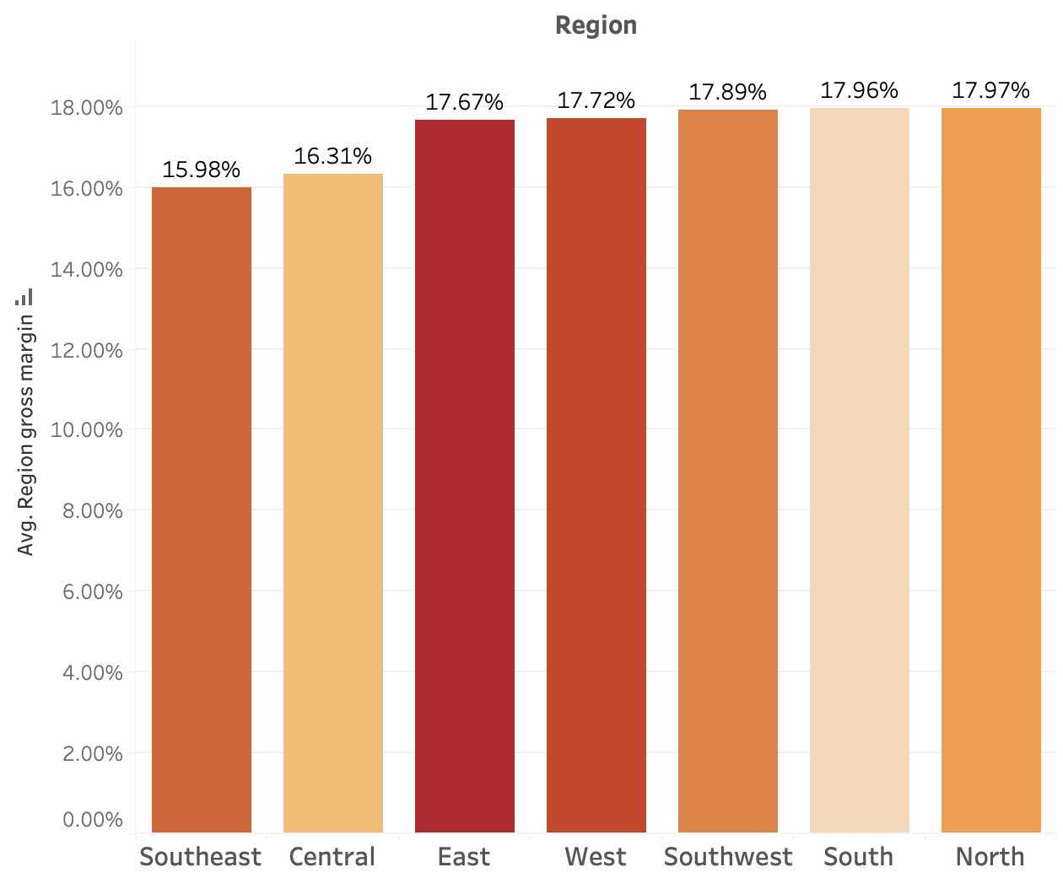
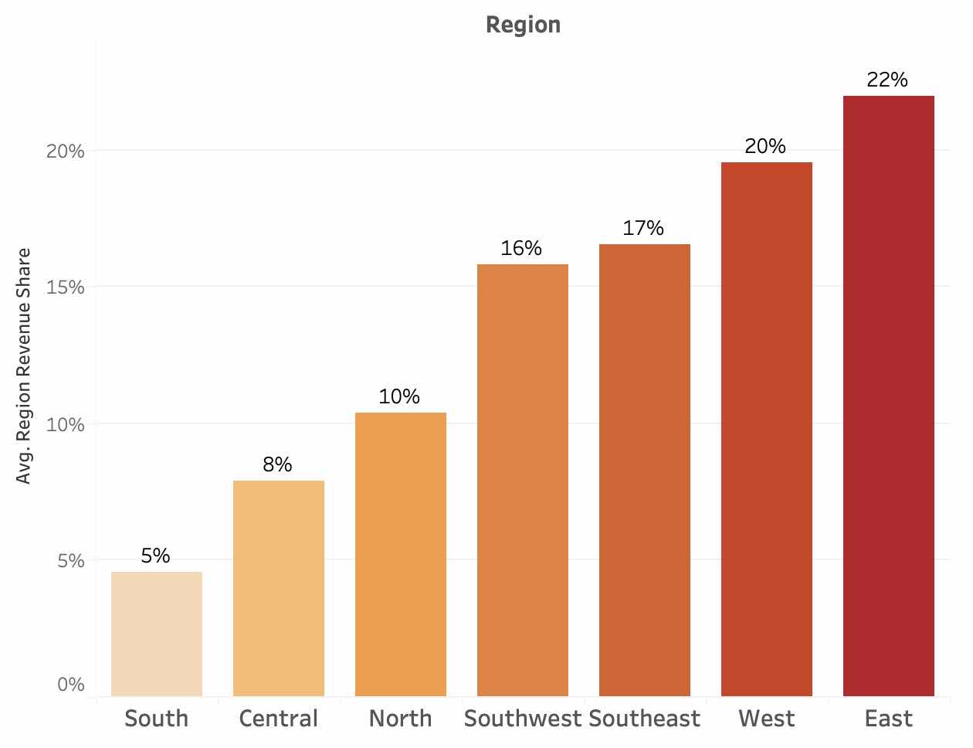
Graph 2.1.1 Pangdonglai wage structure table for 2024 and 2025
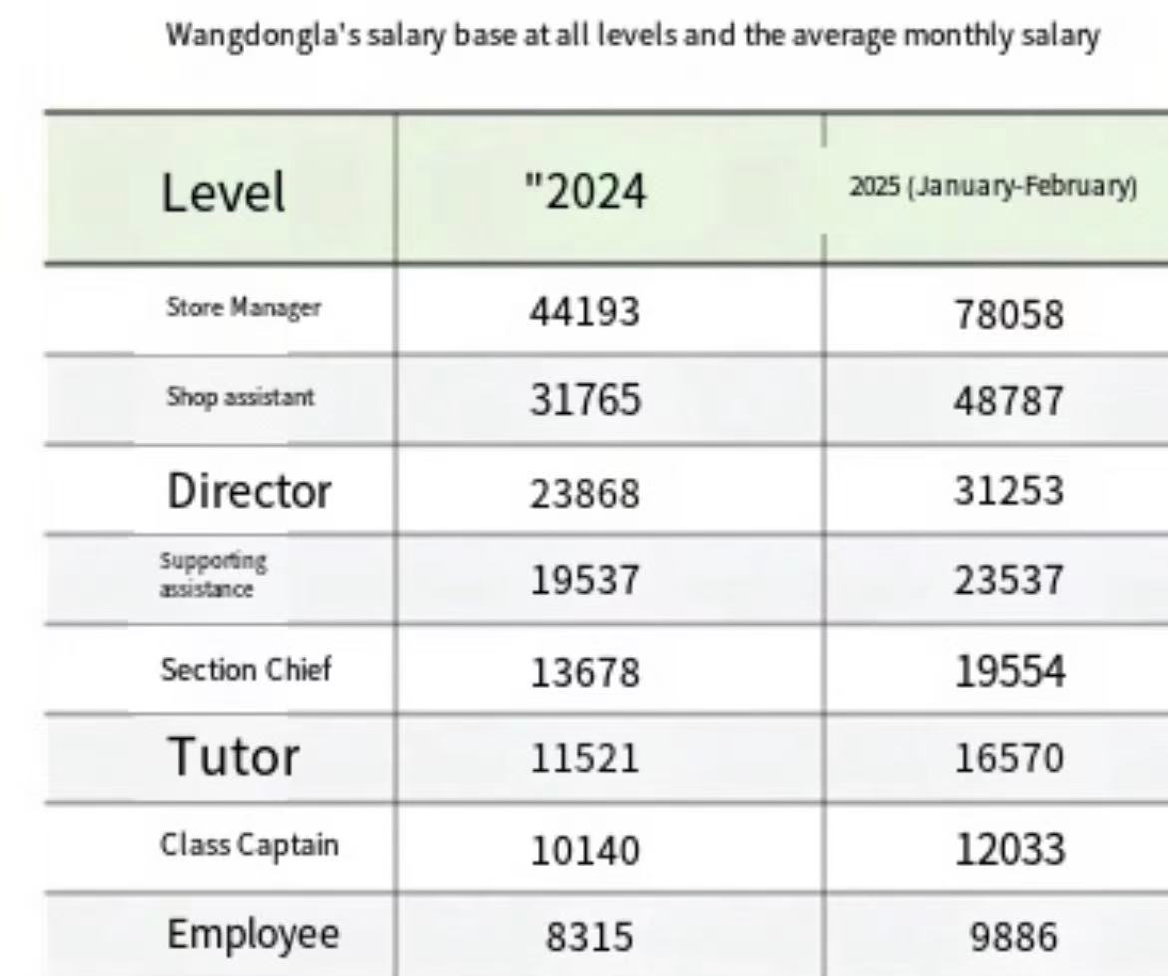
Graph 2.3 Financial Performance after Transformation (2024-2025)
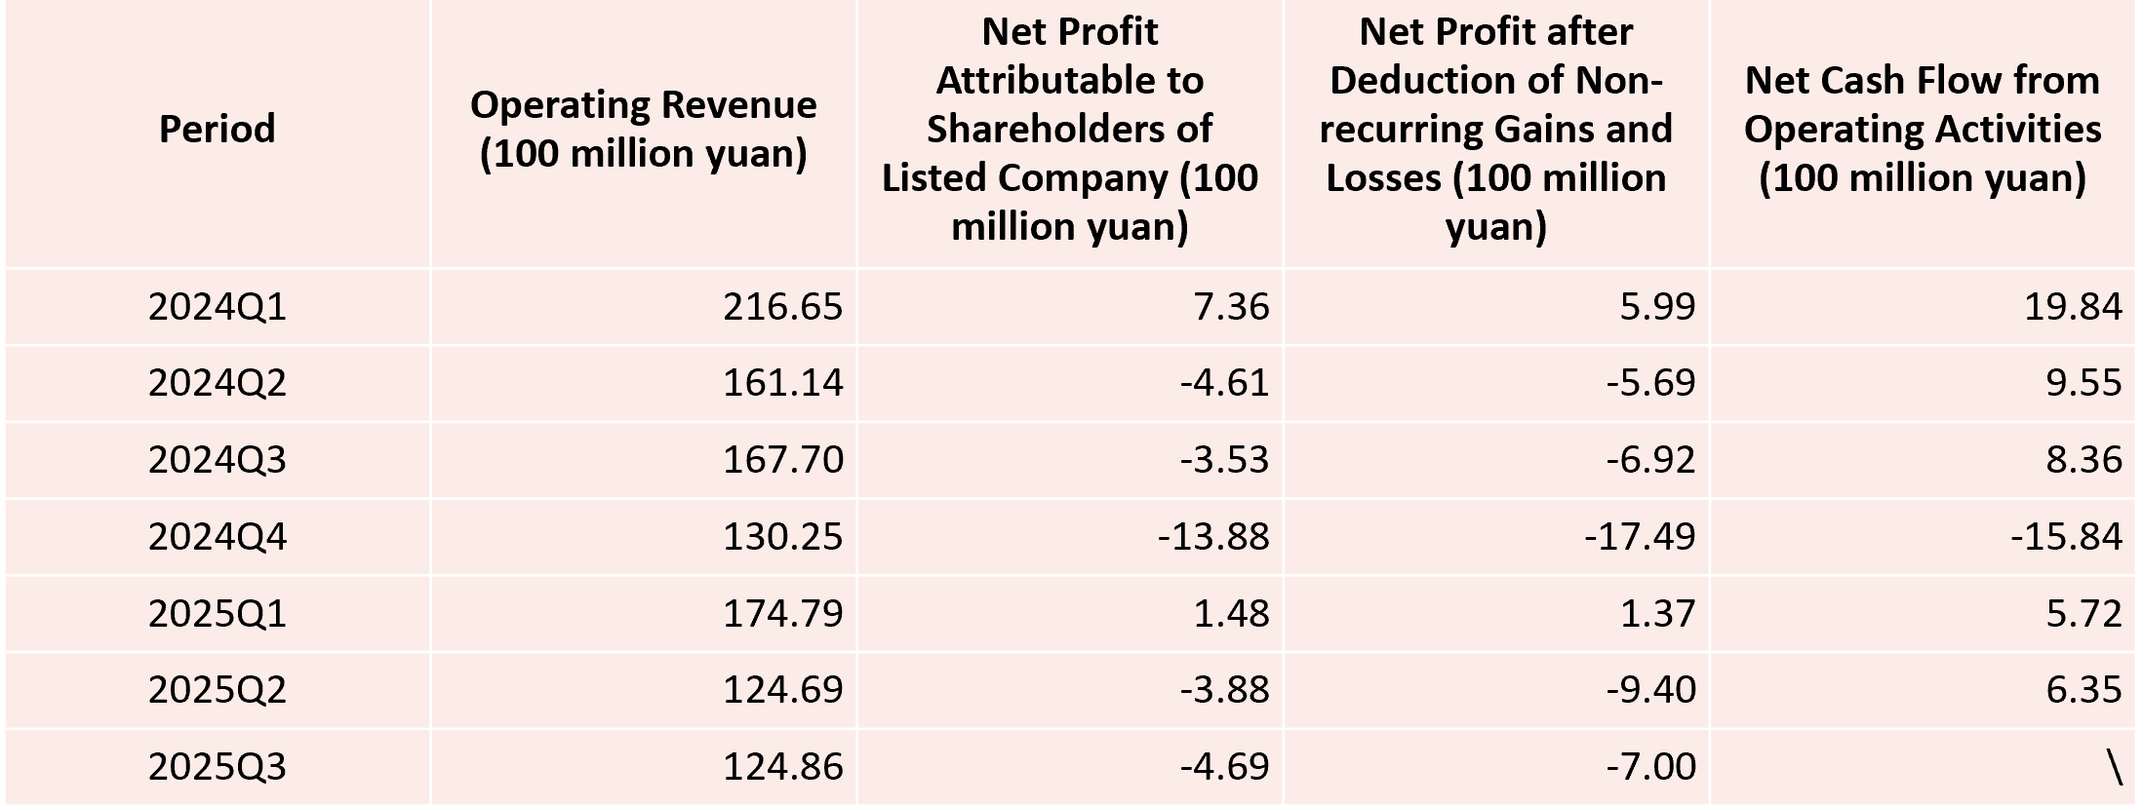
Graph 2.3 Operating Revenue Change (2024-2025)

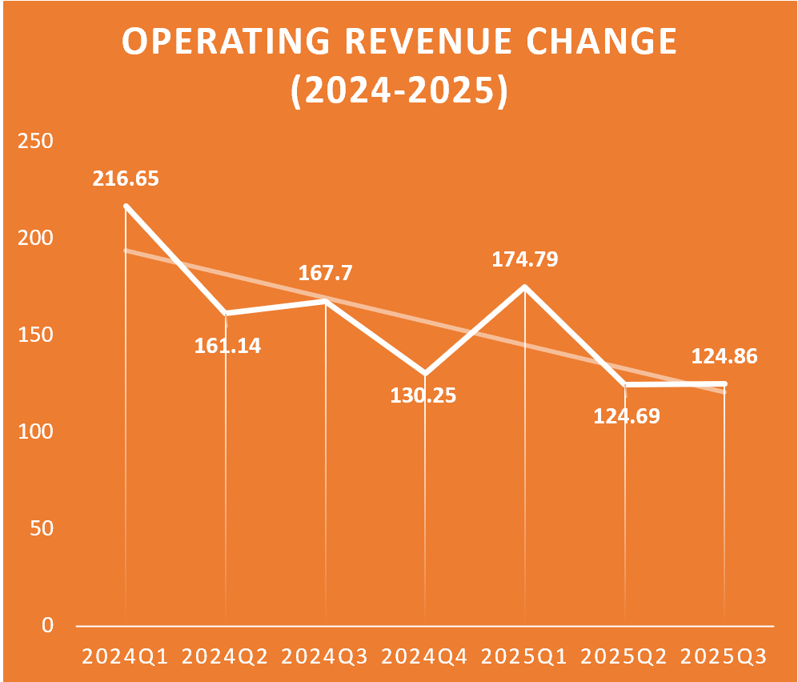
Graph 2.3 Profit Change (2024-2025)
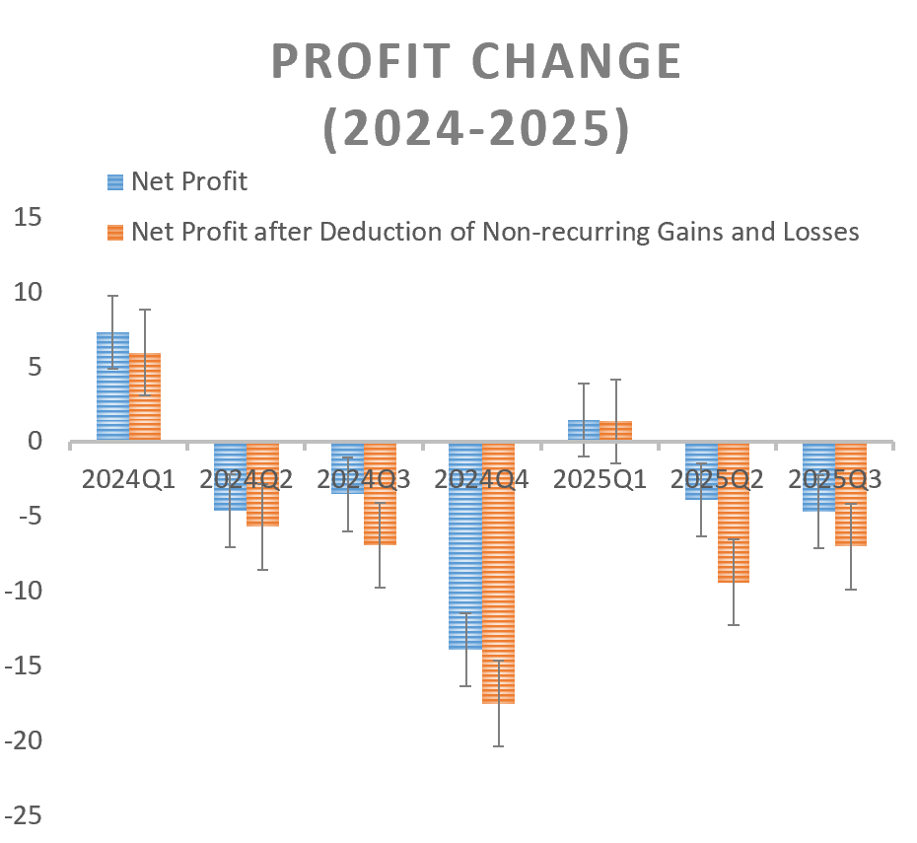
Graph 2.4 Yonghui Annual Stock Return and Transformation Events (2019–2025)
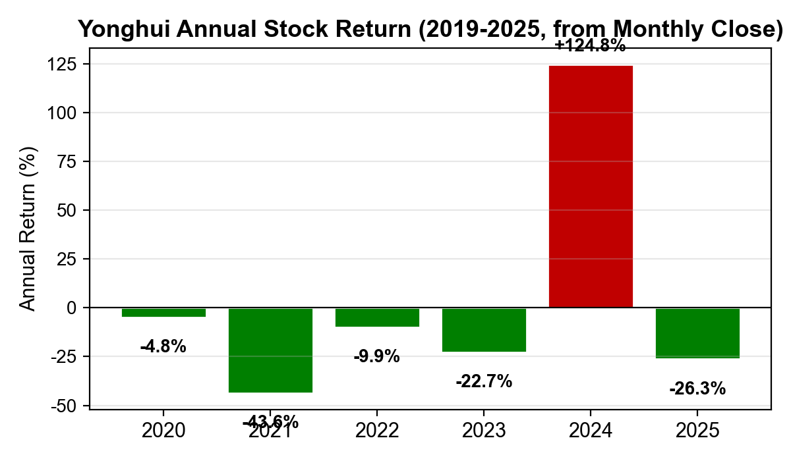
Yonghui Superstores (601933) historical stock trading data (daily and monthly, CSMAR TRD_Dalyr and TRD_Mnth) was used to calculate annual returns and event-study windows around transformation announcements.

Appendix 2 Reference Source
1.Yonghui Superstores Co., Ltd. (2024, May 27). Yonghui Superstores announces store optimization and adjustment plan. https://www.yonghui.com.cn/html/web/latestnews/yonghuixinwen/1954817324876058626.html
- Yi, D. (2024, June 5). How Pang Donglai became a retail benchmark: Reflections on Pang Donglai’s transformation of Bubugao and Yonghui Superstores (Industry research report). Tebon Securities.
- The historical financial data (Revenue, Gross Profit, Net Profit, etc.) for Yonghui Superstores (601933) from 2020 to 2024 was sourced from the publicly available financial portal Eastmoney.com .Access Link: https://quote.eastmoney.com/concept/sh601933.html#finance
- The historical financial data (Operating Revenue, Gross Profit, Net Profit, etc.) for Yonghui Superstores (601933) from 2024 to 2025 was sourced from the official website of Yonghui Supermarket where the company publicly releases its quarterly and annual financial reports (e.g., 2025 Third Quarterly Report, 2024 Annual Report). Access Link:https://www.yonghui.com.cn/html/web/touzizheguanxi/dingqibaogao/index.html
- Historical sales data for 2020 to 2024 from Fat Donglai are derived from Fat Donglai‘s official website and interview data, where the company publicly publishes its quarterly and annual sales data. Access link:
https://web.azpdl.cn/sale/info
- Ge, S. (2024) Why Pangdonglai – the persistence and transformation of a “network celebrity” supermarket, Xinhuanet. Available at: https://www.news.cn/fortune/20241008/ae395f208ac74e0d81537c43116f55c6/c.html

